FOOD ALLERGIES AND FOOD SENSITIVITIES FOR UNDER 16s

We use this form to collect information about under 16s who are visiting the Chocolatarium without their parent/guardian. This form should completed by the Lead Adult (usually the Class Teacher, Parent of the birthday girl/boy, Scout/Guide Leader, Group Leader).

Please share the Food Allergies & Food Sensitivities Guide for Parents/Guardians leaflet with the parent/guardian of all the children attending.
Every effort has made to avoid the use of products containing allergens and to provide vegan and halal options wherever possible. We have had many visitors with allergies and food sensitivities successfully visit the Chocolatarium. However, risk can never be completely eliminated. The Chocolatarium Ltd cannot accept any liability for illness or injury from products consumed during or after the visit. Please let us know if you or any parent/guardian would like further information and any suggestions or requests for how to reduce risk further are always welcome.

Please use the table below to tell us of any Food Allergies or Food Sensitivities of any of the children in your group.
Please write S for Severe allergy and M for mild allergy. You do not need to list children who have no food allergies or sensitivities.

Severe means that the child’s allergy could cause serious illness or be life-threatening. It is essential that children with severe allergies or strict dietary requirements are accompanied by an adult who carries and is trained and authorised to administer any necessary medication in the unlikely event that it is required.

Name of Child | Cereals containing gluten | Milk | Eggs | Nuts | Peanuts | Sesame Seeds | Soya | Sulphur Dioxide | Vegan | Halal | Other  Please give details | Should not consume any product during the visit.  Type N for not to consume.
 |  | 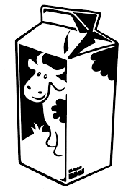 |  | 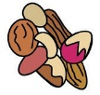 | 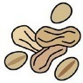 |  |  | 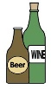 |  | حلال‎
Example:  Mary Jones |  |  |  |  | S

Data Protection
We will only use this data and share it with third parties for the protection of the health of our visitors. Third parties include a) medical professionals, b) Chocolatarium Ltd. staff and c) other adults who are assisting with the visit.

☐ I confirm that a parent/guardian of all of the under 16s I will be bringing to the Chocolatarium have given their permission for their child to attend.

☐ I confirm that I have shared the Food Allergies & Food Sensitivities Guide for Parents/Guardians leaflet with the parent/guardian of all the children attending.

☐ I confirm that I have collected information from either official documentation or directly with parents/guardians and have listed all individuals who have a Food Allergy or Food Sensitivity.

☐ I understand the as the Lead Adult I am ultimately responsible for the children during their visit to the Chocolatarium.

Lead Adult Name
Lead Adult Signature*
Date

*A typed name sent from the email address used for booking is accepted as equivalent to a wet signature.

